Aim: Determination of the saponification value of fat sample

Video: https://www.youtube.com/watch?v=ersHDsiAVko

Principle: Fats (triglycerides) upon alkaline hydrolysis (either with KOH or NaOH ) yield glycerol and potassium or sodium salts of fatty acids (soap) .

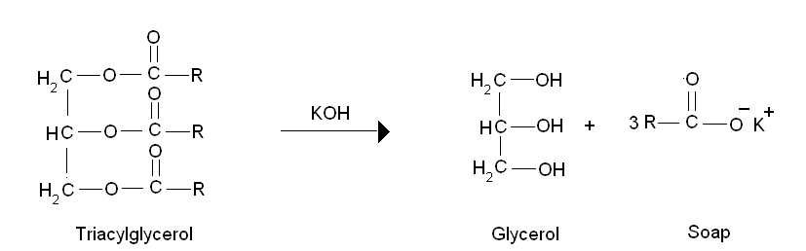

The saponification number is the number of milligrams of potassium hydroxide required to neutralize the fatty acids resulting from the complete hydrolysis of 1g of fat .

It gives information concerning the character of the fatty acids of the fat- the longer the carbon chain, the less acid is liberated per gram of fat hydrolysed. It is also considered as a measure of the average molecular weight (or chain length) of all the fatty acids present.

The long chain fatty acids found in fats have low saponification value because they have a relatively fewer number of carboxylic functional groups per unit mass of the fat and therefore high molecular weight .

Materials Required:
1) Fats and Oils [coconut oil, sunflower oil]
2) Conical Flask
3) 100ml beaker
4) Weigh Balance
5) Dropper
6) Reflux condenser
7) Boiling Water bath
8) Glass pipette (25ml)
9) Burette

Reagents Required:
1) Ethanolic KOH(95% ethanol, v/v)
2) Potassium hydroxide [0.5N]
3) Fat solvent
4) Hydrochloric acid[0.5N]
5) Phenolphthalein indicator

Procedure:
1) Weigh 1g of fat in a tared beaker and dissolve in about 3ml of the fat solvent [ ethanol /ether mixture].
2) Quantitatively transfer the contents of the beaker three times with a further 7ml of the solvent.
3) Add 25ml of 0.5N alcoholic KOH and mix well, attach this to a reflux condenser.
4) Set up another reflux condenser as the blank with all other reagents present except the fat.
5) Place both the flasks in a boiling water bath for 30 minutes .
6) Cool the flasks to room temperature .
7) Now add phenolphthalein indicator to both the flasks and titrate with 0.5N HCl .
8) Note down the endpoint of blank and test .
9) The difference between the blank and test reading gives the number of millilitres of 0.5N KOH required to saponify 1g of fat.
10) Calculate the saponification value using the formula :

Saponification value or number of fat = mg of KOH consumed by 1g of fat.
Weight of KOH = Normality of KOH * Equivalent weight* volume of KOH in litres
Volume of KOH consumed by 1g fat = [Blank – test]ml

